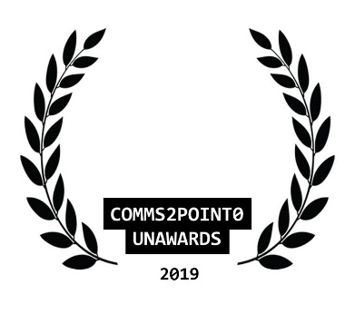
#UnAwards19 ENTRY // NOMINATION FORM
Please complete this entry form and email it to admin@comms2point0unawards.co.uk by 30 October 2019 (midnight)
You are able to send one piece of supporting information to help with your entry (but please only send one as our judges will not be able to look at any more than this) Thanks.
your name

your email address

your organisational @twitter
your personal @twitter [optional]
category entered

name of organisation/team/individual being entered/nominated

name of entry
date project delivered [to / from]
campaign/project budget

brief description of objectives

brief outline of strategy/plan
what did you deliver and how did you measure it?

what were the outcomes/benefits?

tell us why you should win
[in no more than 100 words]
NEW  comms2point0 are looking to build a new ‘’best practice resource with CAN Digital.  Are you happy for this entry to feature here? Thanks. | Yes or No

